**Autoregressive model**

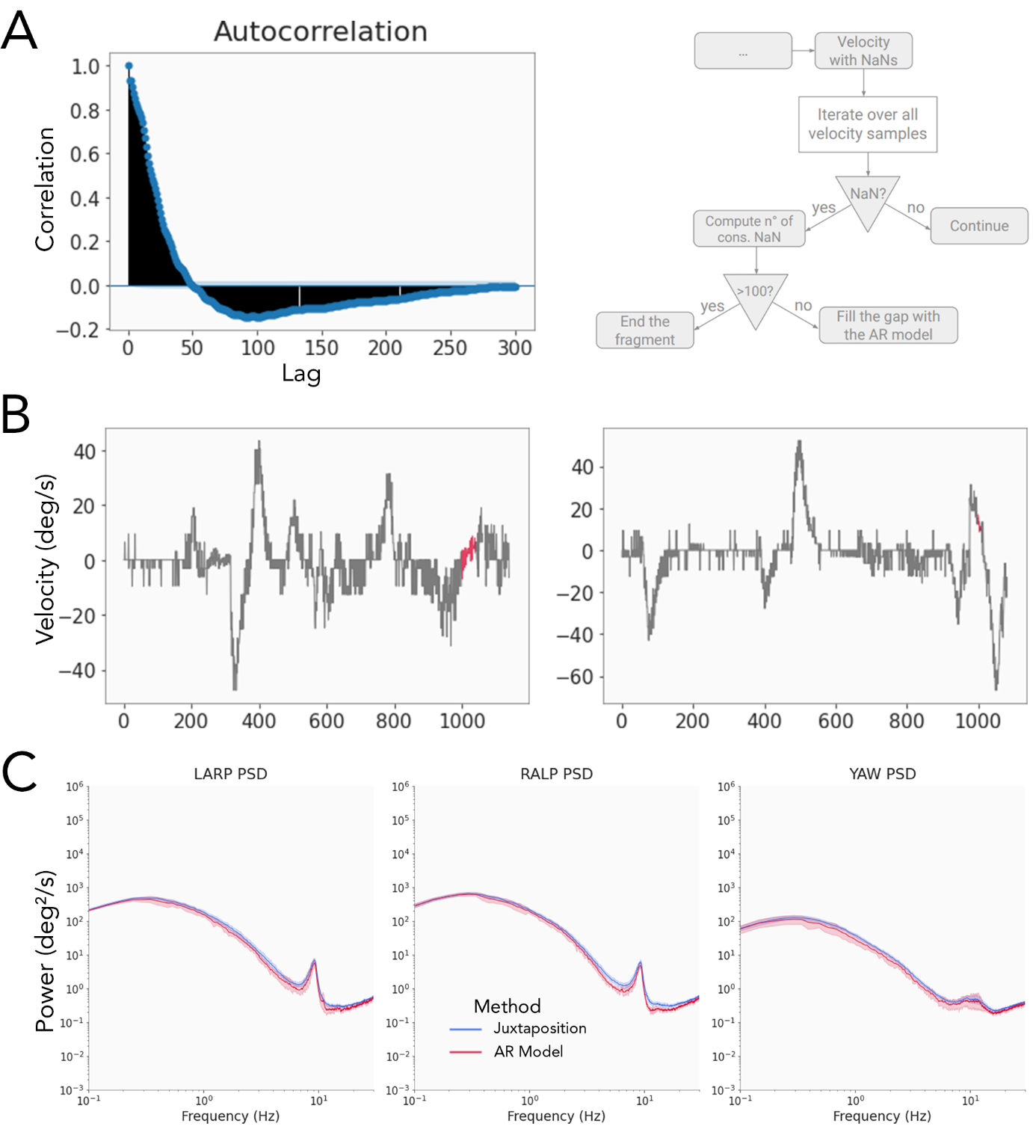

Supplementary Figure 2:

Panel A: Left: autocorrelation function of the head velocity signal. Correlation decreases steadily until a lag of 50 time steps where it changes sign. From there it rises again in absolute value until a lag of 100 time steps before decreasing again to zero for a lag of 300 time steps. Panel A: Right: schematic representation of the processing of raw head data.

Panel B: Head angular velocity in the LARP plane after applying the AR model. Both curves present the first 10 seconds of training data (in grey) followed by the completion of the gap by the AR model (red) and the next 1 s of true data (grey).

Panel C: Population-averaged power spectra of the head-velocity in the LARP, RALP and YAW planes with corresponding 95% confidence interval (shaded areas). Blue: power spectra obtained with the simple juxtaposition method (detailed in section Materials and Methods, Data preprocessing), red: power spectra obtained after applying our AR Model.

An autoregressive (AR) model predicts future values of a time series using its previous values. Such a model is appropriate for our data since the angular velocity of the head is auto correlated: the future velocity of the head depends closely on the immediate previous velocities (see Panel A, left). After removing samples with a low quality, we are left with ‘gaps’ in the time series. We employed an AR model (AutoReg function from the statsmodel python package, which estimates an AR-X model using Conditional Maximum Likelihood) to fill these gaps with data. To avoid generating erroneous data, we restrained the maximum length of a gap to be less than one second. If the number of successive discarded values (samples with a quality value < 0.5) resulted in a gap greater than one second in length, the current ‘data fragment’ was ended and a new fragment was created at the end of the gap. Otherwise, we used the AR model to fill the gap. The model was trained on the ten seconds of data preceding each gap. We chose a number of lags in the model as a linear function of the size of the gap: from 30 lags if the gap’s size is of length 1 (only one sample discarded) up to 300 lags if the gap’s size is of length 100 (100 successive samples discarded). Panel A, right, schematically represents the general idea of the algorithm.

Panel B shows two applications of the AR model on a pilot’s head angular velocity signal.Each gap appears to be completed with appropriate data samples. After application of our AR model, we obtain a collection of relatively clean, evenly sampled measurements of angular velocity signals. These can then be processed traditionally using Welch’s method to obtain the power spectra. We further chose to only consider fragments exceeding 3 minutes for analysis to focus on the more robust parts of the recordings. Panel C compares the power spectra obtained with the two methods discussed in this article (the simple ‘juxtaposition’ method and the AR model). Clearly, both methods produce comparable results.